**High Level thinking for building Components:**

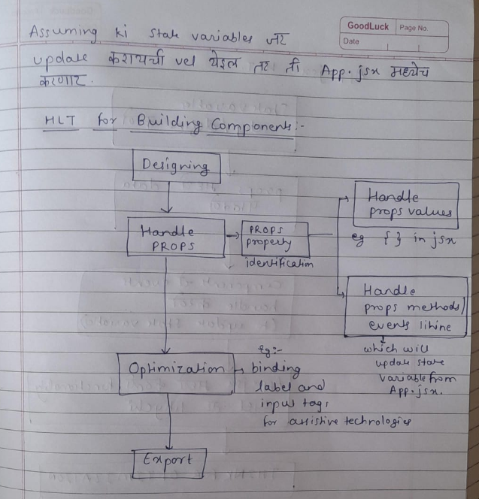

**High Level thinking for building App.jsx**

